Data visualization process

My first thought went I saw the data was to charts would be appropriate based on the information we had.

For each of our dataset, we had 3 columns:

**Stop** – The name of each stop

**AvgOn-** The average number of people getting on the bus

**AvgOff**- The average number of people getting off the bus

The main goal of the visualization is to point out any stop that is being underused or overused so we can make some suggestions.

As you look at the Gold Line

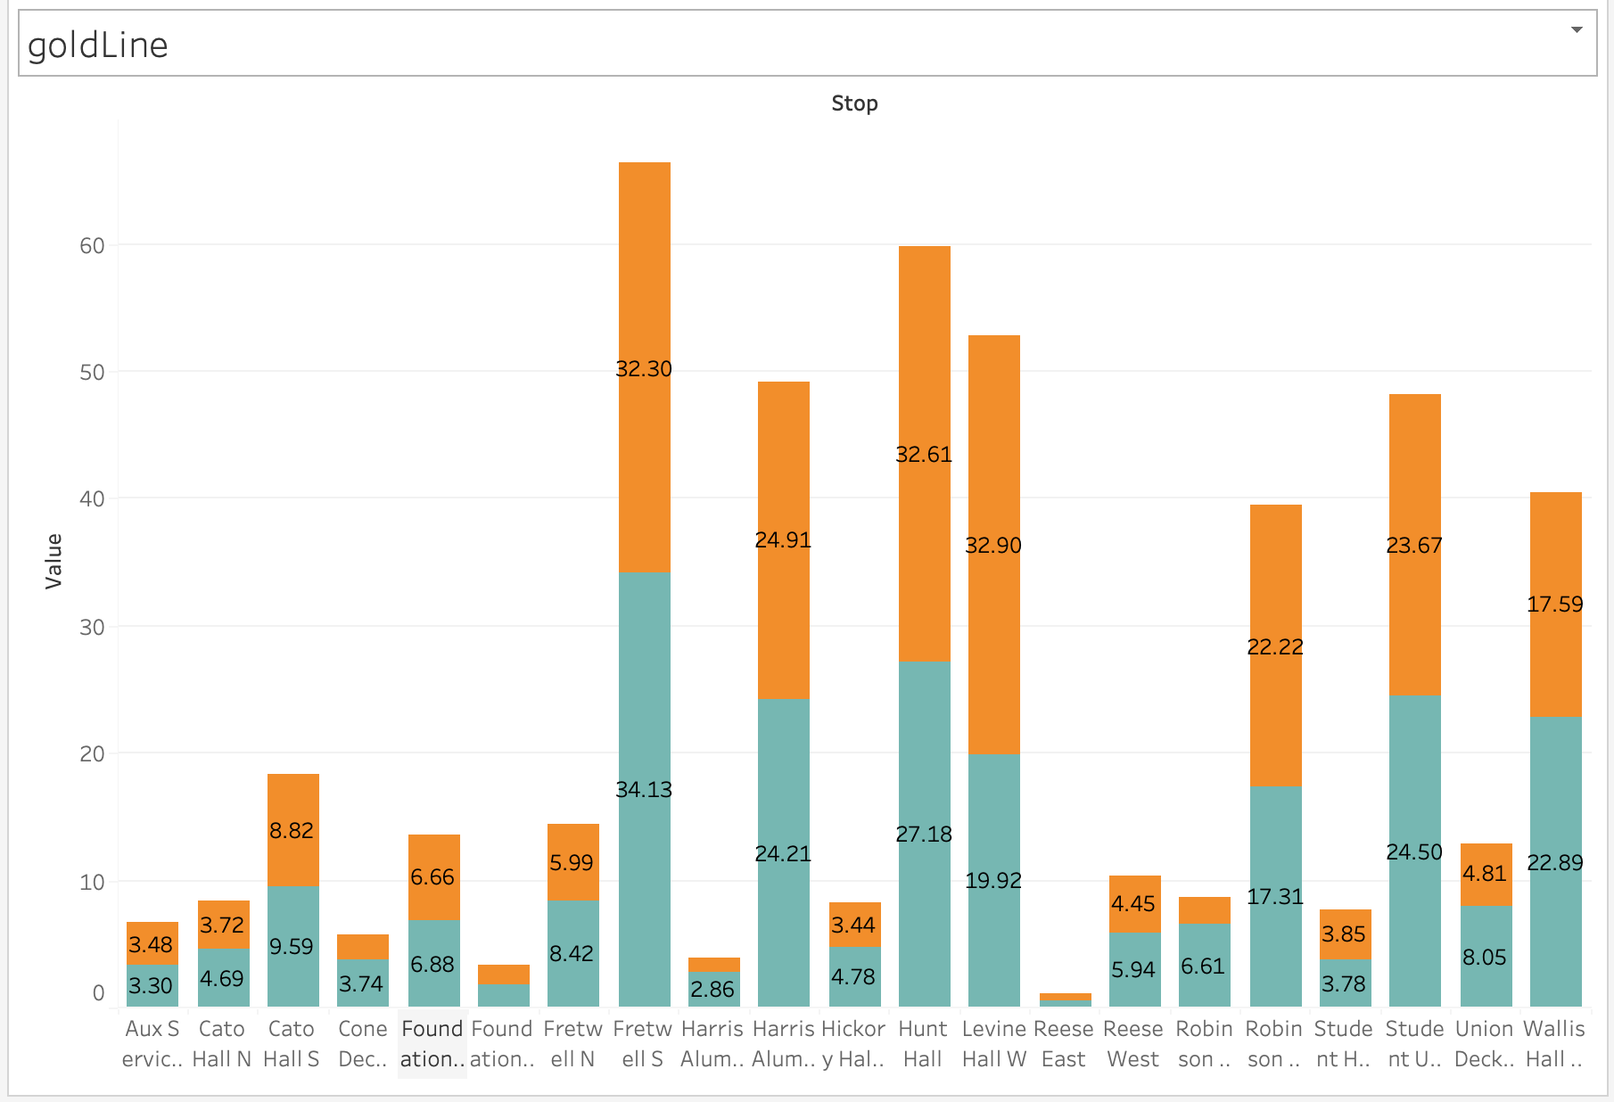

The “Foundation Bldg South” is being underused here with an average of only 1 person getting on and off the bus

Using these kind of information could help determinate if we need to make some cuts to optimize the routes of each bus.